Traffic Simulation Assignment Report
Assignment Number: 1
Name: Hiten Mulmi
Roll Number: 45
1. Summary of Work
This project presents a real-time traffic simulation of a four-way intersection developed using C++ and the SDL3 graphics library. The goal of the simulation is to model realistic traffic behavior by incorporating vehicle movement physics, traffic signal control, and lane-based constraints. The system supports dynamic vehicle spawning, smooth acceleration and deceleration, collision avoidance, and turning movements implemented through parametric curves. A distinctive aspect of the simulation is its asymmetric road design, with special emphasis on Road A (North). In this road, only the central lane is designated for incoming traffic, while the outer lanes function as outgoing lanes. This configuration introduces non-uniform traffic flow and adds realism to the model.
Additionally, the project includes an adaptive traffic light system that adjusts signal timing based on real-time congestion levels. Lane densities are continuously monitored, allowing the system to prioritize heavily congested lanes and improve overall traffic throughput.
2. Data structure used
Several data structures were nested to manage the simulation efficiently and maintain code readability.
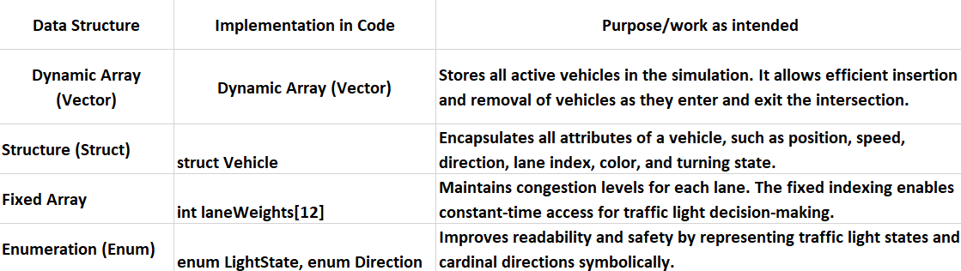

3. Implementation
The following core functions utilize the above data structures to drive the simulation logic:
•spawnVehicle()
Creates new vehicle objects with randomized properties and inserts them into the traffic vector. This function enforces asymmetric spawning rules, particularly for Roads A and C.
•isPathObstructed(Vehicle& v)
Checks whether a vehicle’s path is blocked by other vehicles or traffic lights. It iterates through the traffic vector to maintain safe following distances and prevent collisions.
•manageTrafficLights()
Uses lane weight data to determine which traffic direction should receive the green signal. The function dynamically adjusts light phases based on congestion levels.
•main() (Simulation Loop)
Acts as the core control loop. It updates vehicle physics, manages traffic signals, and handles rendering every frame.

